PHASE 7: PROJECT DOCUMENTATION PHASE

Documentation
The complete implementation process is documented step by step.
The documentation includes:

1. Spreadsheet Preparation
Details about creating and downloading the employee spreadsheet.

2. Employee Test Table
Documentation of the custom table and its fields:
- Employee ID
- Employee Name
- Email
- Department
- Location

3. Import Set
Documentation of the Employee Import table and the data-loading process.

4. Transform Map
Documentation of:
- Source Table
- Target Table
- Field Mapping
- Auto Map Matching Fields
- Mapping Assist
- Transform execution

5. Coalesce
The documentation explains how Coalesce is configured to avoid duplicate employee records.

6. Reports
The following reports are documented:
- Employees by Department
- Employees by Location
- Employee List Report

7. Dashboard
The Employee Analytics Dashboard and the process of adding reports to it are documented.

Final Documentation
The documentation provides a complete record of the ServiceNow project from initial spreadsheet preparation to data import, validation, reporting and dashboard creation.
Inserting New Data In Excel Format

Steps :
- Navigate to All menus.
- Search for Load data Under System Import set Open Load Data.
- Fill the details as
- Import set table as select Existing table {Employee Import}.
- Source of Import is Select File and choose the file from Files.
- Sheet number : 1, Header row : 1.
- Now Click submit.
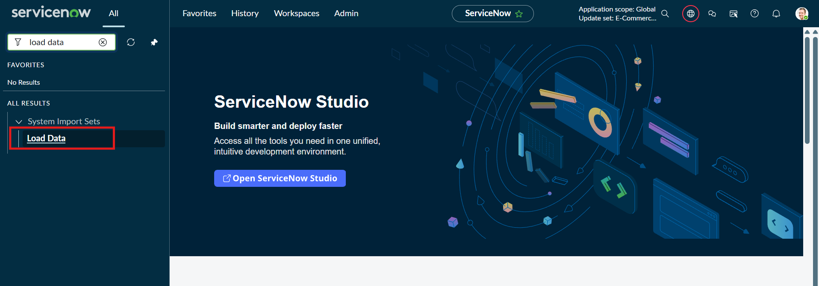
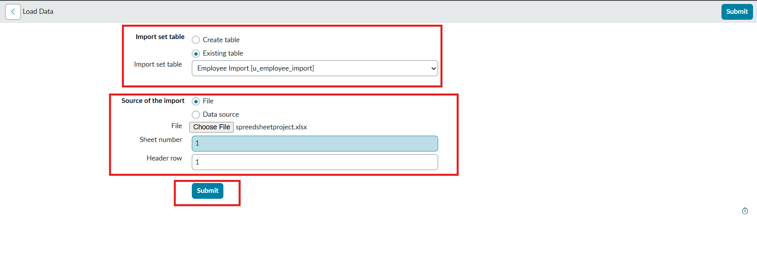

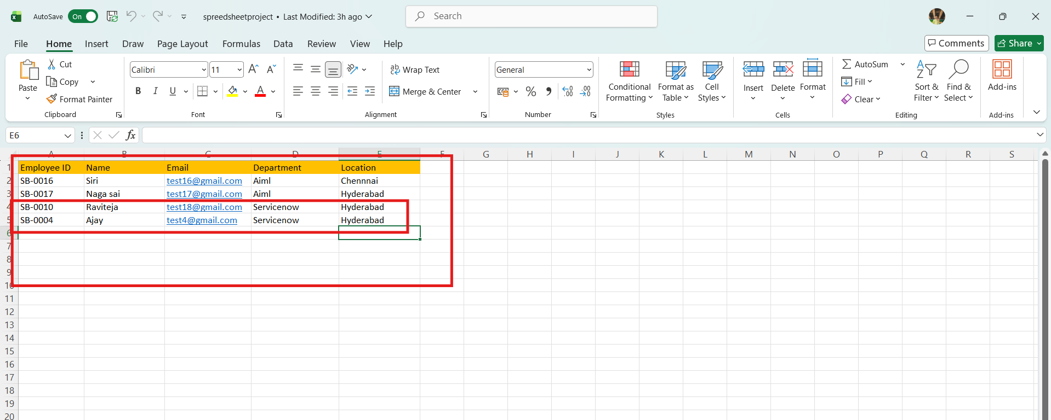
- Newly Created Excel Data is this.
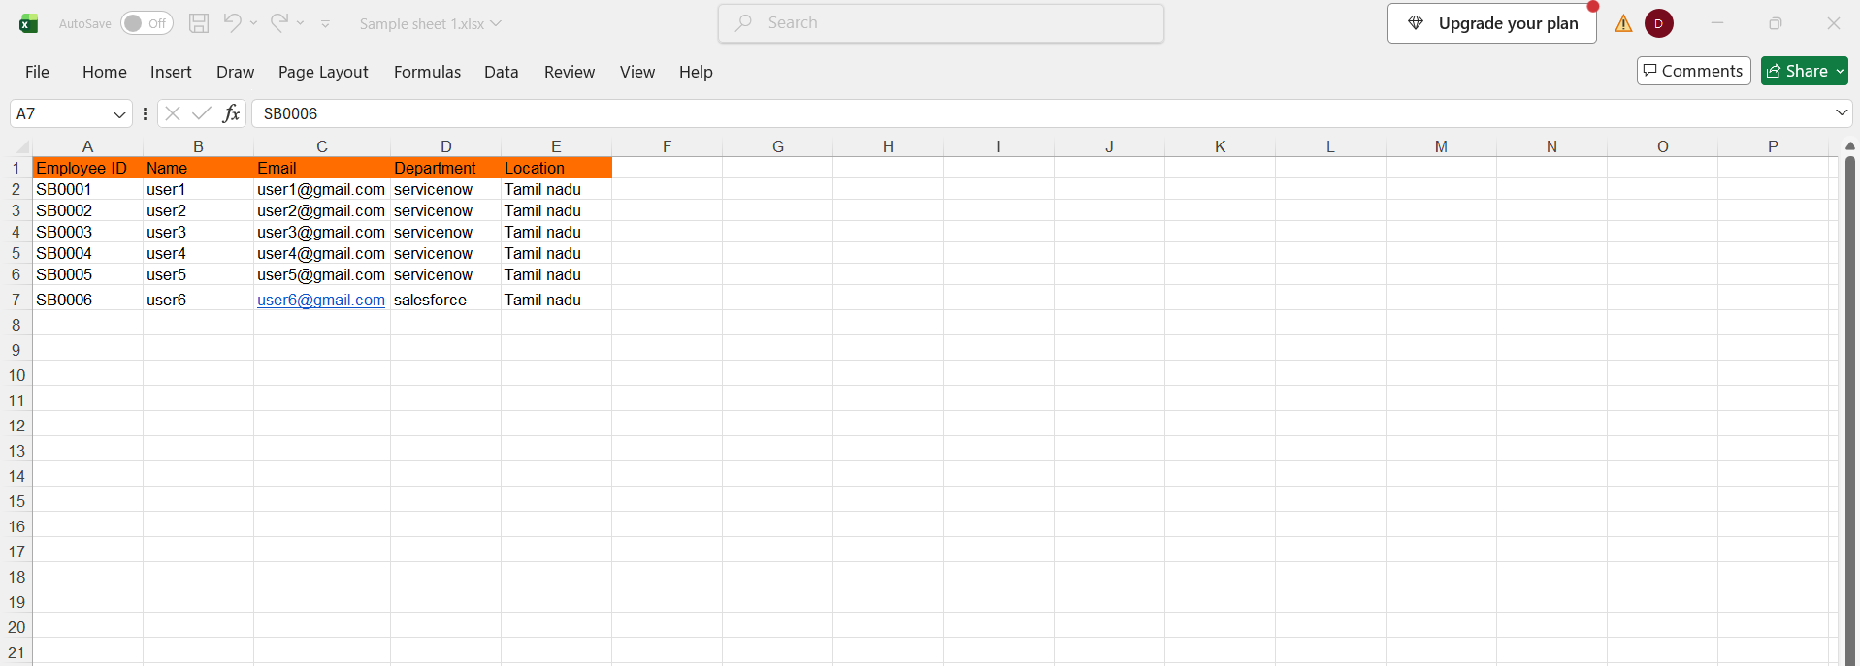
- It is the previously added data.
- Now, In this new data we added 4 rows of the 2 rows with the same existing data with different Name changed and Email changed.
- That Raviteja Employee Email was Changed to
[test10@gmail.com → test18@gmail.com ].
- And Employee ID with SB-OOO4 name was changed to
[Ajay kumar → Ajay].
- And two other new Employee ID’s are added.
- Now after submitting the form it appears as State Completed and Success.
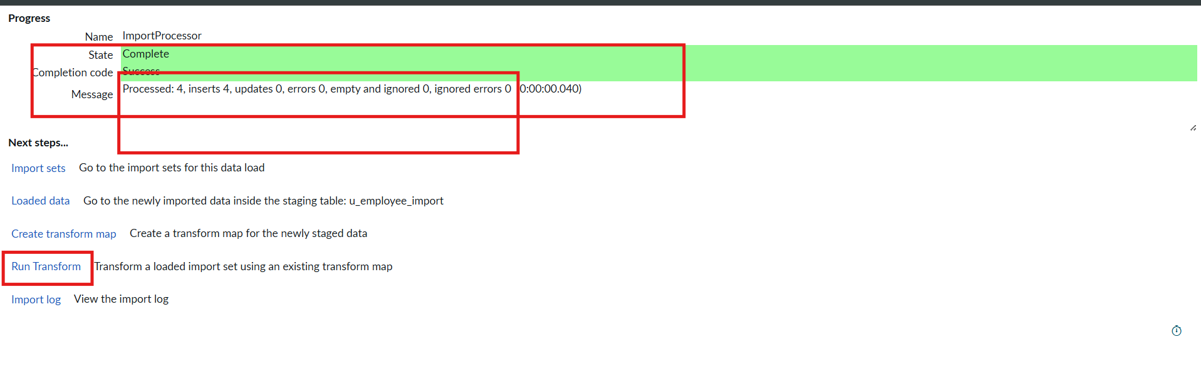

- Now Click the Run transform Under the next steps.
- Then it opens Specify Import set and transform map which is previously selected transform map then Click Transform button.

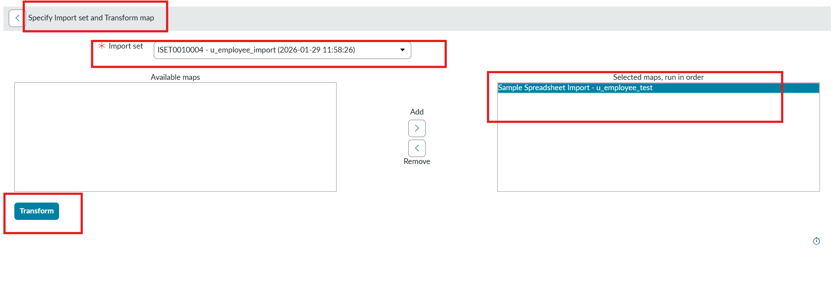
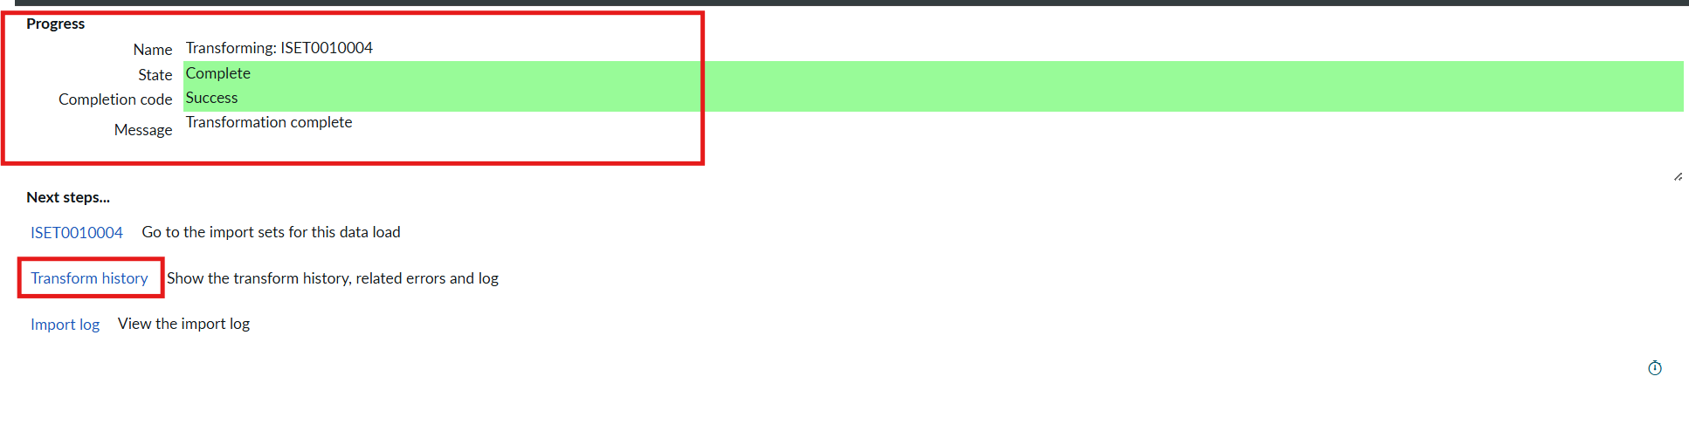
- Now the State is completed and Success.
- Now again click on the Transform history then it shows the newly added data and its status of Inserted and Skipped values out the given data.
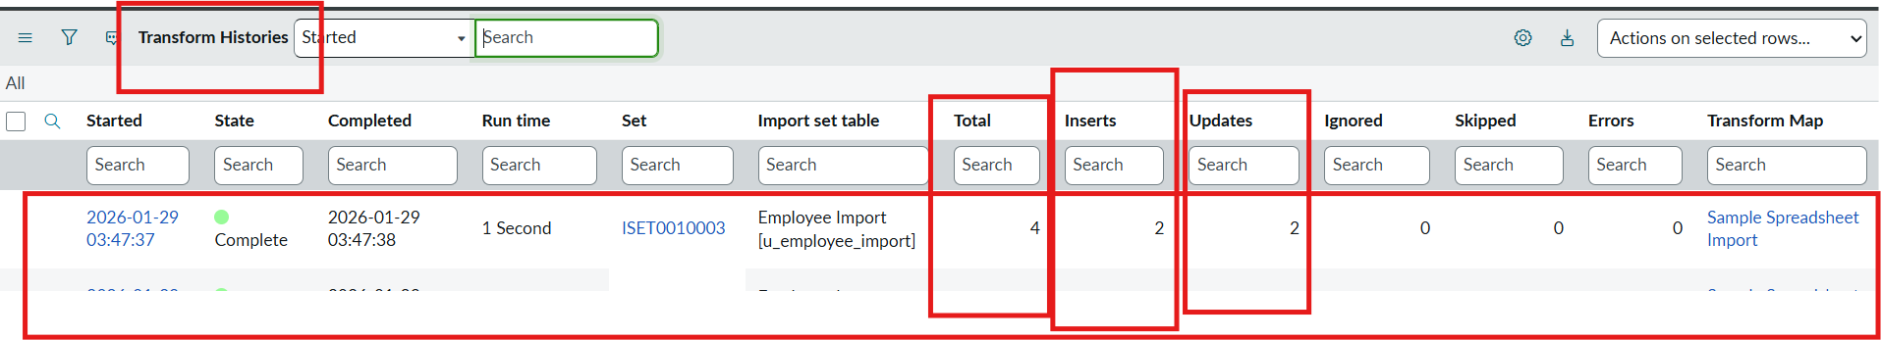
- From the above figure : total 4 rows are uploaded out of 2 are Inserted that are two new ID’s.
- And 2 rows are updates that are Same ID’s with different Name and different Email that we changed.
- Then Open the Employee Tests table and see the rows updated and inserted.
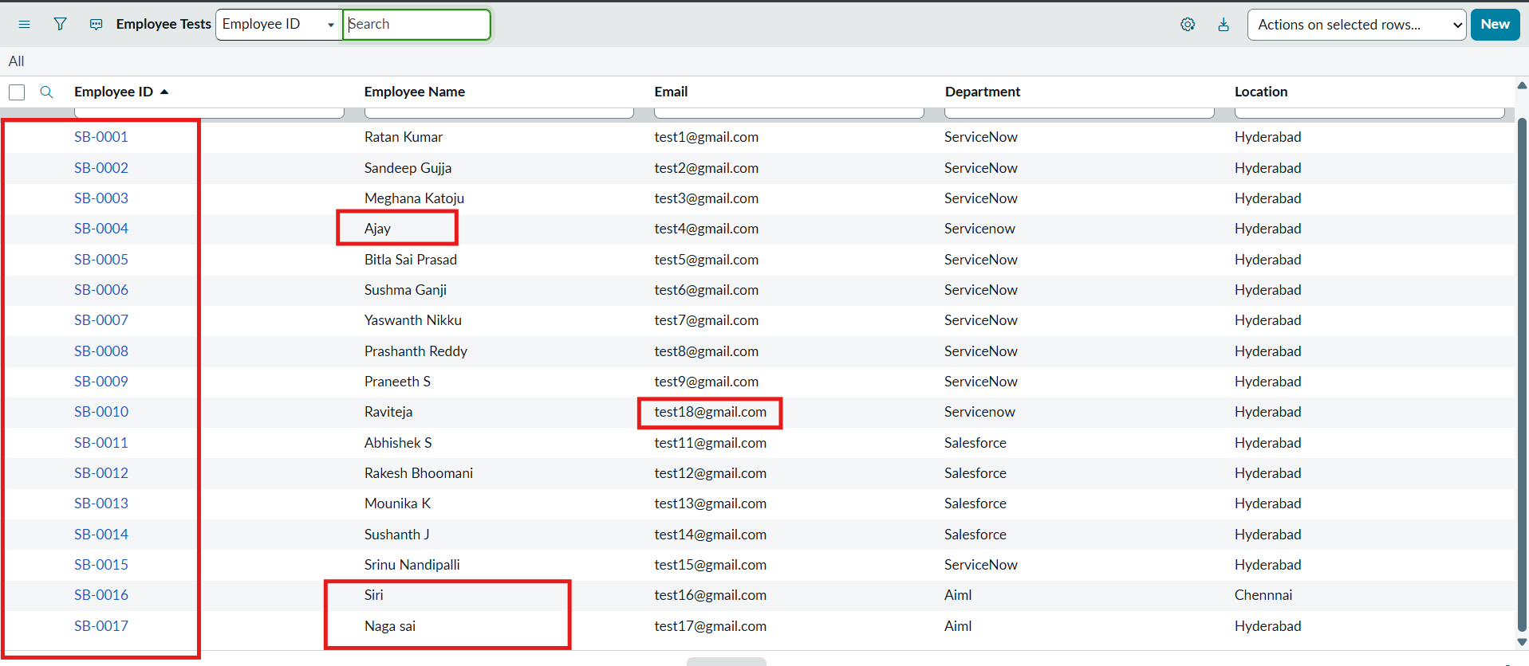

- Now Repeat the Phase 7 with the same steps and same Excel sheet and Submit to check how many rows are updated and Inserted with the same data.
- Then Open the Transform history to check.
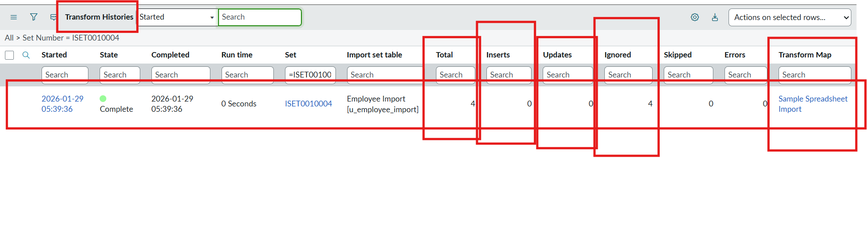
- Here we can see the total 4 are uploaded.
- On that 0 rows are Inserted and updates 0 and Ignored 4 rows.
- That same sheet we uploaded to the same transform map we created.

